This chapter discusses the abilities of multimodal generative AI. It combines text, images, audio, and video to create smart solutions for various generative AI applications. It starts with real-world examples, like an online store using text or images to suggest personalized products with relevance scores. The emphasis is on foundational models from Amazon Titan and Anthropic Claude. These generative AI systems can handle multiple modes, producing both text and images. You can also generate videos based on scripts and offer insights from different types of data. You will discover important ideas such as cross-modal attention and shared latent spaces. You will also look into advanced structures like transformers. This chapter covers how these concepts affect different areas, including e-commerce, healthcare, media, and education. It also addresses ethical issues like bias and the risks associated with deepfakes. Understanding the technical, practical, and ethical aspects of multimodal AI will equip you to innovate responsibly and explore new opportunities in AI applications.

# **19.1 Introduction to Multimodal Generative AI**



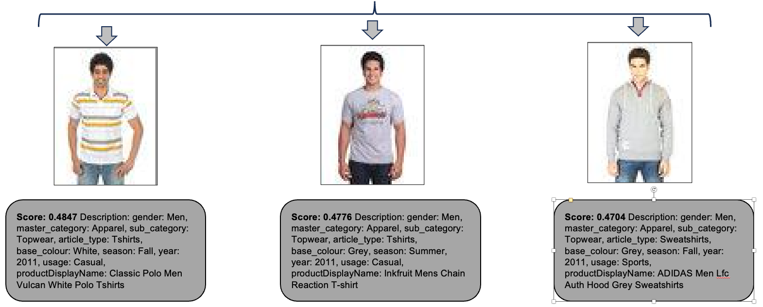

*Figure 19.1 Example of search capability with a simple text prompt*

Initially, you will learn few practical examples. Then you will drive deep into the concept of multimodal generative AI. AnyCompany is an online retail platform that focuses on fashion and lifestyle items. As a customer, your goal is to navigate the online store and make a purchase. You will concentrate on two specific scenarios while there are numerous potential use cases. Imagine you want to search the online store using a text prompt, hoping to receive a selection of the best apparel tailored to your request. Additionally, you would like to see a list of these apparel accompanied by a confident score indicating their relevance or confidence level based on your inquiry (figure 19.1).

Imagine a different use case, such as a single image of clothing. You're looking for product recommendations that are similar to the apparel you liked. Additionally, you want a list of this apparel, along with a confident score that reflects its relevance or confidence level in relation to your inquiry (figure 19.2).

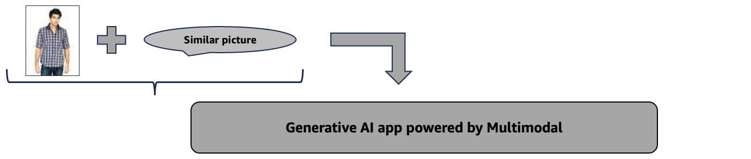

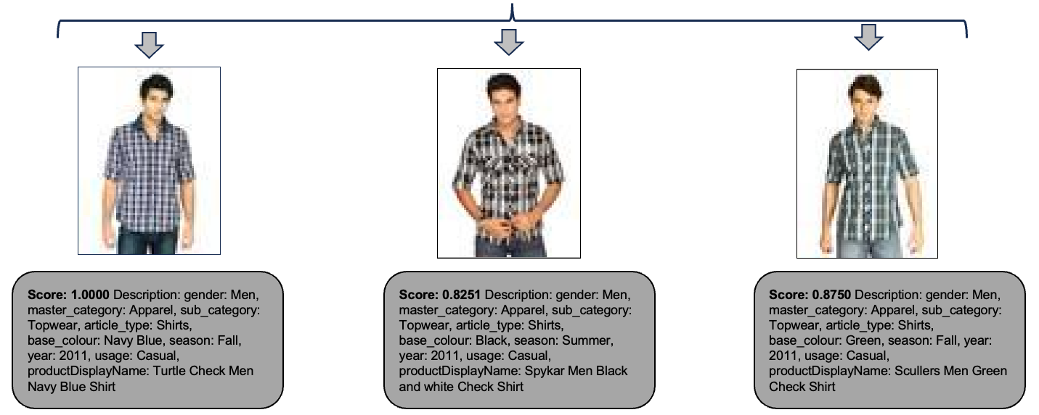

*Figure 19.1 Example of search capability features a combination of text and image prompts*

Images are taken from <https://huggingface.co/datasets/ashraq/fashion-product-images-small>

Dataset for figures 19.1 and 19.2.

You will learn to solve both the above business use cases in this chapter. Let's explore the idea of multimodal generative AI. The term modal refers to a particular type or form of data, like text, images, audio, or video. Multimodal generative AI is a kind of artificial intelligence that can process and integrate various data types, including text, images, audio, and video. In contrast to single-modal systems, which only work with one type of data (like text alone), multimodal generative AI uses various data types to produce more detailed and context-aware results. These systems connect different sensory inputs, resembling human thinking, which makes them more adaptable and effective in processing and creating complex information. For example, Claude 3 Opus and Claude 3 Sonnet from Anthropic can process both text and images. This capability shows combining different modalities can improve user interaction and understanding, moving from single modal to multimodal generative AI systems. The development of multimodal AI started with single modal systems that concentrated on specific areas, like natural language processing or computer vision. In the beginning, machine learning applications included things like image classifiers and language translators individually. These early systems had limitations because you relied on a single type of data. With the advent of deep learning, it became possible to combine different types of data. Methods such as convolutional neural networks for images and recurrent neural networks for sequences helped establish the foundation for multimodal systems.

Different modes like text, images, audio, and video are changing how industries innovate. In user experience, foundation model from Amazon Titan or Anthropic Claude improve interactions by understanding more than just text, including images. Creative fields utilize multimodal models such as Anthropic Claude to generate visuals from text, thereby transforming art, design, and advertising. In healthcare, technology helps with early diagnosis and personalized treatments by examining different patient information. Education and accessibility benefit from interactive learning tools and text-to-image or image-to-text features, making it easier for learner. In media and entertainment, multimodal generative AI supports automatic subtitle creation, video analysis, and personalized content suggestions. By fostering human-level understanding and creativity, multimodal generative AI unlocks transformative possibilities while addressing complex challenges, paving the way for unprecedented growth and impact in intelligent systems.

# **19.2 Understanding the Functioning of Multimodal Generative AI**

This section presents an overview of key components of multimodal generative AI. This section will concentrate on the transformer architecture outlined in Chapter 1. Here, the component encoders receive input data from multiple modalities, including text, images, and audio. This data is transformed into a unified representation.

Encoder focuses on unique features from different types of input. This helps the multimodal system effectively comprehend various data forms. After processing the data, the decoders create outputs designed for specific tasks. This might include creating an image from text or answering questions with both text and visuals.

A crucial concept is cross-modal attention mechanisms. These mechanisms enable the model to identify links between different data types. For example, in image captioning or subtitle generation, the attention mechanism emphasizes certain areas of an image that relate to the descriptive text, resulting in coherent and contextually.

(Refer https://www.sciencedirect.com/science/article/abs/pii/S1361841522002407)

A key technique in multimodal systems is aligning different modalities into a shared latent space, a mathematical representation where data from text, images, and other modalities coexist. Models learn by using pairs of different types, like images and text. This allows them to grasp how these modalities relate to each other. With this knowledge, you can mix or change between modalities easily. As a result, you can produce videos based on text descriptions or create audio from images.

CLIP, or Contrastive Language-Image Pretraining, is a foundational model created by OpenAI. It aligns images and text in a shared latent space. It enables tasks like zero-shot image classification, image search, and captioning without requiring task-specific datasets. The architecture of CLIP exemplifies the power of cross-modal alignment, enabling the pairing of a text description such as "a photo of a smiling girl" with the corresponding image, even in unseen data.

(Refer <https://paperswithcode.com/method/clip>)

Amazon Titan although primarily known for text-based generative tasks, Titan demonstrates multimodal potential when integrated with Amazon's broader AI ecosystem, such as AWS Amazon Rekognition (for images) and Amazon Transcribe (for audio). Titan, for instance, highlights the integration of various modalities into workflows like media analytics or interactive content creation by generating contextual text summaries from video content that Rekognition has analyzed.

Furthermore, Anthropic Claude is known for its focus on ethical and responsible AI. Claude has multimodal capabilities. It is capable of processing both text and images simultaneously. This allows Claude to examine infographics and summarize the information they contain.

This demonstrates how multimodal generative AI is evolving toward more intuitive and interactive systems. For example, you developed an e-commerce app with Amazon Titan. In this app, you can upload images of products, like running shoes. It uses AWS Rekognition to examine the shoe's features. The app can also process text requests, such as "Show me something similar in black" to suggest related items. Titan combines insights from both the image and text to enhance user experience through cross-modal integration. The main elements of multimodal generative AI and its foundational models enable significant advancements in various fields.

# **19.3 Progress and Innovations in Multimodal Generative Models**

Multimodal generative AI is changing many industries. It enables different data types to collaborate. This helps address a wide range of use cases. Amazon Titan and Anthropic Claude are examples of this technology in action. They provide businesses with features like generating text from images and creating videos, along with other cognitive services from AWS.  
These developments enhance efficiency. They also foster more engaging and inclusive experiences for you in various areas. Recent advancements in multimodal generative AI have led to significant progress. Foundational models now enable a deep understanding and generation across different data types. Modern generative AI models combine text, audio, video, and images. They are trained on diverse datasets. Advanced architectures like transformers enable these models to understand and generate text like humans do. Certain foundation models can create intricate images based on text descriptions. These advancements will benefit creative design and product development. Amazon Titan can generate marketing materials and product prototypes using text and images. These models also enhance accessibility and searchability through automatic image captioning. Amazon Titan works with Amazon Rekognition to summarize images for e-commerce.

The Anthropic Claude model possesses the capability to comprehend both textual and visual information. This capability allows for the execution of complex tasks, including story creation and the provision of audio descriptions for videos.

Multimodal generative AI models incorporate capabilities for text generation from images and video creation from text. Amazon Titan analyzes images with Amazon Rekognition to create engaging product descriptions, like tailored marketing content for laptops. Although dynamic video creation from text isn't fully developed yet, improvements in foundational models are paving the way. These innovations could streamline video production, allowing brands to make marketing videos or explainer animations directly from scripts. Some potential use cases.

|  |  |
| --- | --- |
| **Industry** | **Use cases** |
| E-Commerce | Amazon Titan works with Amazon Rekognition to improve how products are searched and recommended. For instance, if you upload a picture of a jacket, the system will examine its characteristics. It can then create text descriptions or recommend similar products, like matching shoes, making shopping easier and more enjoyable. |
| Healthcare | Claude can analyze multimodal data, such as X-rays and patient history, to assist healthcare professionals in generating diagnostic reports, illustrating how multimodal generative AI contributes to precision medicine. |
| Media and Entertainment | Multimodal models help automate the creation of captions, subtitles, and even video scripts. For example, Titan could generate tailored video summaries from movie scripts or raw footage, streamlining content production workflows along with Amazon Rekognition. |
| Education and Accessibility | Claude’s ability to process and explain multimodal data can make educational materials more engaging and accessible. For example, it could generate text-based descriptions of complex diagrams for visually impaired learners along with text to speech service Amazon Polly. |

*Table 19.1 Example of potential industry use cases*

# **19.4 Addressing Challenges in Multimodal Generative AI**

To realize the full potential of multimodal generative AI, it is important to address its potential challenges. The following are critical steps: addressing ethical concerns, maintaining high data quality, utilizing resources efficiently, and enhancing collaboration between various modalities. You can develop robust multimodal applications by looking at these viewpoints.

#### **Challenges in Modality Fusion Alignment**

Challenges in modality fusion and alignment arise from the inherent differences in the structures and semantics of diverse data types such as text, images, and audio. Text data is sequential, images are spatial, and audio is temporal, making it difficult to combine these modalities into a unified representation. Using models such as CLIP, it is possible to successfully link text and images together. On the other hand, their performance could suffer when they attempt to incorporate a variety of data formats, such as text, photos, and audio. Several recent developments have resulted in the introduction of cross-modal attention processes. By utilizing latent alignment, these strategies contribute to the enhancement of integration. On the other hand, additional improvements are still required to accomplish seamless modality fusion, which will thereby enable multimodal systems that are more effective and efficient.

#### **Handling Noisy and Incomplete Datasets**

Multimodal generative AI models struggle with datasets that are noisy, incomplete, or unbalanced. These models need large, varied, and high-quality datasets to identify useful patterns. However, many datasets have problems. They often contain noisy data, which includes irrelevant or mislabelled information. Datasets may not always be complete and can miss certain types of data. For instance, if Amazon Titan tries to create product descriptions, its performance might suffer if it has detailed text but very little image information. To address these issues, approaches like advanced data preprocessing techniques such as outlier detection and data augmentation are employed to handle noise. Multimodal data imputation is an effective technique. It employs foundation models to address missing data in different formats. For example, if an image is absent, a text prompt can create comparable features for that image. This method aids in restoring lost information, enhancing the accuracy and performance of models that handle various data types.

#### **Scaling Multimodal Models Efficiently**

Scalability poses a significant challenge for multimodal generative AI models due to their high computational demands. These models need to process complex data from multiple sources simultaneously. Training these models demands a lot of memory and processing power. This need grows significantly as more modalities are included. For instance, some advanced foundation model, which works with six modalities, shows how resource needs increase with each new modality. To tackle scalability problems, different methods are used. Model compression techniques, such as pruning and quantisation, help lower the computational load. Efficient designs, such as transformers with sparse attention, help minimize memory consumption. Even, Amazon SageMaker along with purpose build virtual machine enables scalable multimodal training through distributed computing.

#### **Ethical Challenges in Multimodal generative AI**

Multimodal generative AI models can encounter ethical issues, especially related to bias and deepfake technology misuse. These models can adopt and enhance biases present in their training data, leading to worries about fairness and precision. Their capacity to produce realistic content, such as images and videos, heightens the potential for misuse, especially concerning deepfakes. Models such as Anthropic Claude can create text based on images. This capability could lead to the spread of misinformation. Similarly, a biased dataset can cause Amazon Titan to generate product descriptions that favor certain groups. To tackle these problems, you should implement bias reduction techniques. It's also crucial to regularly review datasets to ensure they are fair. Creating forensic tools can aid in identifying deepfakes. These tools look for inconsistencies, like mismatched lip movements and audio. Finally, establishing ethical guidelines and strict access controls will encourage responsible AI usage and reduce potential harm.

# **19.5 Exploring the Ethical Dimensions of Multimodal Capabilities**

The ethical considerations of multimodal generative AI emphasize the importance of fairness, transparency, and accountability in tech development. To address problems like bias, misuse of deepfakes, and opaque systems, you must act proactively. This involves establishing robust governance, creating new detection methods, and enhancing user controls. Models such as Amazon Titan and Anthropic Claude promote innovation while upholding ethical principles. This strategy builds trust and guarantees responsible usage. It allows you to explore various aspects throughout your development process.

#### **Ensuring Fairness in Multimodal Capabilities**

Fairness and reducing bias in multimodal AI are crucial. These models can highlight biases present in their training data, particularly when integrating various types of information. For example, a hiring tool that assesses resumes and video interviews could unintentionally favor certain candidates based on gender or race because of biased data. To address this issue, it is essential to develop diverse and inclusive datasets. Conducting regular fairness audits and improving model transparency with clear designs are important measures to lessen discrimination and foster trust in these technologies.

#### **Risks of Multimodal Deepfakes and misuse**

Creating realistic multimodal content, like synchronized video and audio, comes with serious risks. These include the potential for deepfake technology to spread misinformation, commit fraud, or violate privacy. For instance, multimodal generative AI can produce fake videos showing people saying or doing things they never actually did. This makes it difficult to identify these counterfeit items. Forensic tools help spot differences between audio and visuals. This is important for managing risks. Moreover, content watermarking can be used. It adds digital signatures that confirm the content's authenticity. Amazon launched watermarking methods to prevent misuse. Moreover, setting up regulations and ethical guidelines can foster accountability and promote responsible use of multimodal technologies.

#### **Balancing Innovation and Accountability in AI**

It's important to balance innovation with transparency and accountability in multimodal powered applications. These can be intricate, raising concerns among users and stakeholders about their functioning. Models such as Anthropic Claude strive for transparency by clearly explaining their results. However, achieving transparency in complex multimodal systems is not easy. It's important to develop ethical governance frameworks for auditing AI applications. Additionally, flexible data management controls are necessary. For instance, customizing foundation models with Amazon Bedrock Guardrails for text can benefit from independent evaluations. This process would help ensure that the outputs meet ethical standards and effectively support specific tasks.

# **19.6 Sample Application with Multimodal Capability Architecture**

You have already gained knowledge about the multimodal capabilities of generative AI. In Chapter 6, you learned about the RAG architecture, and in Chapter 4, you learned about the concept of embedding. Now, by combining all these ideas, you will gain a comprehensive understanding of the concept, complete with a use case. At the beginning of this chapter, you outlined the actual business requirements in figures 19.1 and 19.2. This section aims to provide you with an understanding of the technical architecture that addresses the identified problems. There are three sections that discuss the technical architecture.

#### **Vector DB Creation**

A multimodal embedding model will embed all the raw product image data, along with meaningful properties, into a vector database. Here, you will use the Amazon Titan Multimodal Embedding model and Amazon OpenSearch serverless as a vector DB. This step needs to be executed at initial stages. An event-driven pipeline will then process the incremental raw data if you need. In this case, the raw data will be stored on Amazon SageMaker's internal volume. However, in practice, you will be using cloud storage, specifically Amazon S3. Refer figure 19.3.

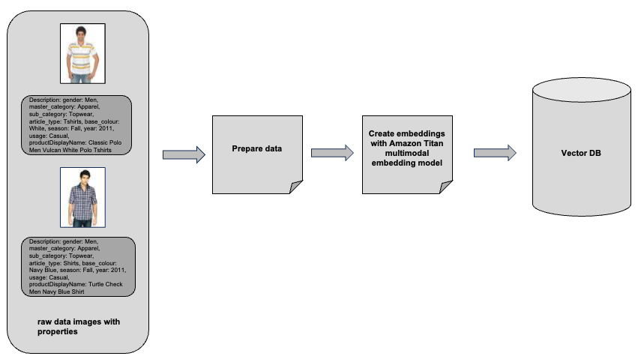

*Figure 19.3 Example of ingesting into vector DB*

#### **Search capability with a simple text prompt**

You will provide the text-based prompt. You will convert the prompt into embeddings. You will perform a similarity search in the vector DB. It will enrich the context with pertinent information once it has been retrieved from the vector database. Finally, generate responses with a generative AI model along with a confidence score for each possible outcome. Refer figure 19.4.

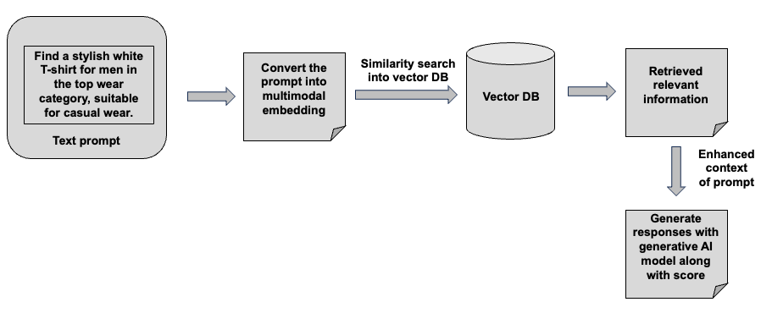

*Figure 19.4 Example of search capability with a simple text prompt*

#### **Search capability features a combination of text and image prompts**

You will provide a combination of the image and text-based prompt. You will convert the prompt into embeddings. You will perform a similarity search in the vector DB. It will enrich the context with pertinent information once it has been retrieved from the vector database. Finally, generate responses with a generative AI model along with a confidence score for each possible outcome. Refer figure 19.5.

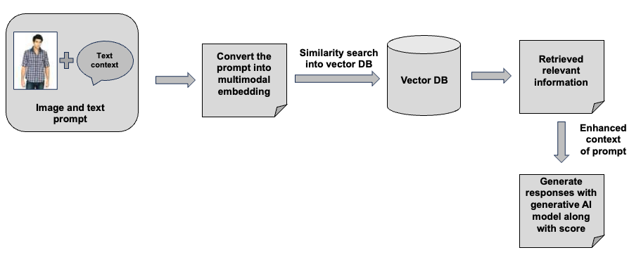

*Figure 19.5 Example of search capability features a combination of text and image prompts*

# **19.7 Sample Application with Multimodal Capability**

To get the GitLab details, refer to the appendix section of this book. In GitLab, locate the repository named **genai-bedrock-book-samples** and click on it.

Inside the **genai-bedrock-book-samples** repository there is an AWS CloudFormation template that resides in the **cloudformation** folder. If you already executed the AWS CloudFormation template in Chapter 3 and didn't delete the stack afterward, you can skip the paragraph highlighted in grey below.

The task requires the execution of an AWS CloudFormation template, which should be performed once for all exercises in this book. A detailed guidance on how to manually execute the AWS CloudFormation template can be found in a file called **README** located within a directory named **cloudformation**. For more information about AWS CloudFormation template refer <https://aws.amazon.com/cloudformation/>.

**Disclaimer**: It is advisable to delete the AWS CloudFormation template if you are not actively participating in any exercises for some longer duration. Clear instructions for deleting the AWS CloudFormation template are provided within the README file itself.

However, in the **genai-bedrock-book-samples** folder there’s another subfolder titled **chapter19**. The **README** file within **chapter19** folder provides clear instructions on launching a **Notebook** on Amazon SageMaker.

|  |  |
| --- | --- |
| **File Name** | **File Description** |
| simple_multimodal_data_prep.ipynb | * Processing a dataset of images, saving them to a specified directory while generating and storing metadata descriptions. * Generates multimodal embeddings by accepting an image or text description, processes the input, and invokes a model via the Bedrock runtime client, returning the resulting embeddings. * Adds multimodal embeddings to each dictionary in image_metadata_list.   **Dependency**:   * simple-sagemaker-bedrock.ipynb at Chapter 3 should work properly. |
| simple_multimodal_knwl_bases_building.ipynb | * Create collection on serverless OpenSearch * Create a network policy for collection * Create a security policy for encryption using an AWS-owned key * Create an access policy for collection to define permissions for the collection and index * Call the create_access_policy method to define permissions for the collection and index * Create a vector search collection in OpenSearch Serverless * Collection will take some time to be "ACTIVE". So, checking when the collection is "ACTIVE" for the next steps * Index Creation on the collection * Search capability with a simple text prompt * Search capability features a combination of text and image prompts   **Dependency**:   * simple_multimodal_data_prep.ipynb at Chapter 19 should work properly. |

# 3.8 Bedrock Interaction Sample Application

**Disclaimer**: Charges will apply upon executing above files. Therefore, it is important not to forget to clean up the kernel after studying the topic. Refer to the clean-up section for instructions on how to properly clean up the kernel.

# **19.8 Summary**

This chapter explores the power of multimodal generative AI. It shows how combining different data types like text, images, audio, and video improves user experiences and fosters innovation in various fields. This chapter provides practical examples, such as e-commerce features like product recommendations and image searches, demonstrating how multimodal generative AI systems work in real life. The main points highlight foundational models like Amazon Titan and Anthropic Claude. These models assist in aligning various data types and are useful in e-commerce, healthcare, media, and accessibility. This chapter covers advanced AI techniques, such as cross-modal attention and transformer architectures, which facilitate the seamless integration of diverse data types. Finally, it addresses challenges like data quality, scalability, and ethical concerns, including fairness and deepfake risks. It emphasises the importance of balancing innovation with accountability and provides strategies for responsible AI use.